***Nagios 4 installation Document:***

1. Go to below url

<https://assets.nagios.com/downloads/nagioscore/docs/nagioscore/4/en/quickstart.html>

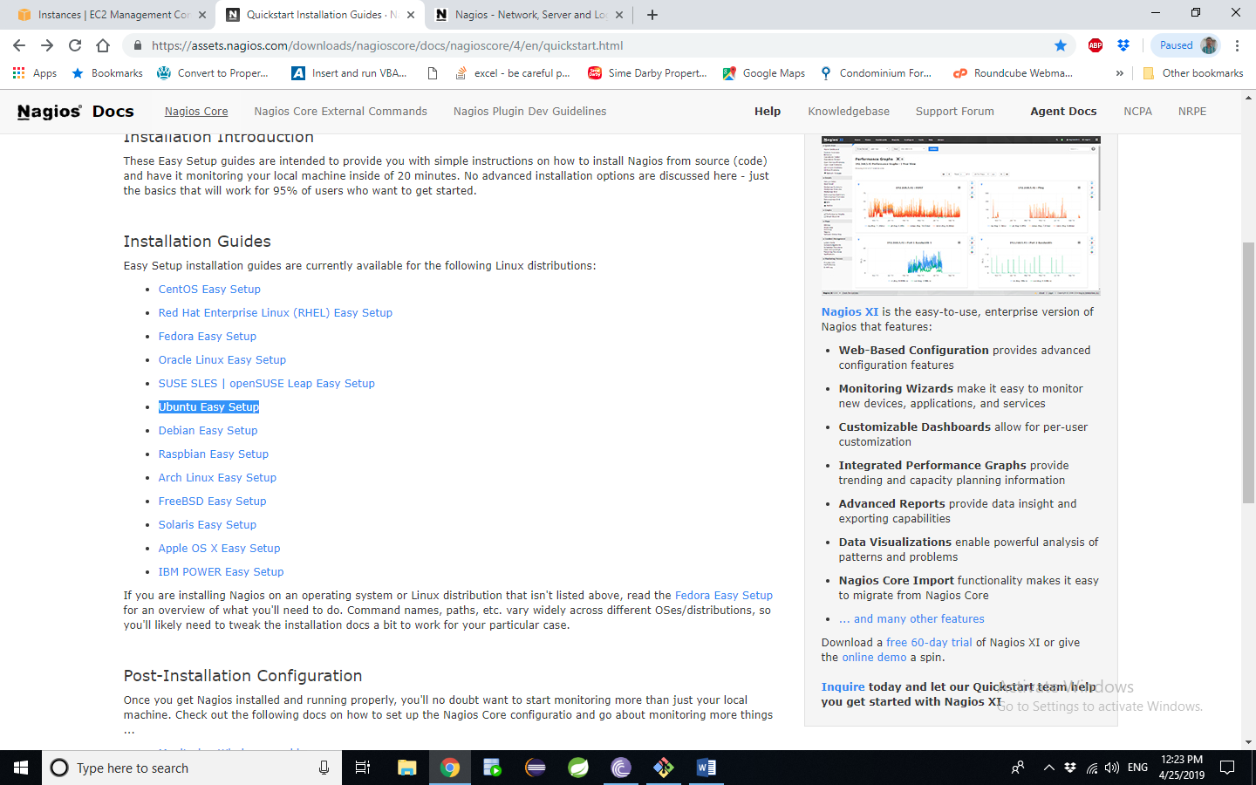

1. Click on the which OS to install the Nagios 4
2. Fallow the document carefully and install the nagios4
3. Setup the Node host in Nagios server
4. Create a directory cd /usr/local/nagios/etc/ (ex:mkdir rameshservers)
5. Go to -🡪/usr/local/nagios/etc open the Nagios file
6. vi nagios.cfg un comment on cfg_dir=/usr/local/nagios/etc/rameshservers

Give your server name

1. Go to this path: /usr/local/nagios/etc/objects
2. Copy the localhost.cfg file to /usr/local/nagios/etc/rameshservers/privatedns.cfg
3. Edit the private DNS.cfg file localhost name, alise name as privatedns and the ip as private ip
4. Run this command to check /usr/local/nagios/bin/nagios -v /usr/local/nagios/etc/nagios.cfg then enter the below command
5. Service nagios restart